This project has been funded with support from the

European Commission. This publication reflects the views only of the author, and the Commission cannot be held responsible for any use which may be made of the information contained therein.

WORK PACKAGE 6

Preparing meals at an elderly person’s home

Topic: | Basic cooking vocabulary
Level: | Basic User A1 to B1
Aim(s): | To practise basic cooking vocabulary in order to be able to communicate with an elderly person who needs help in preparing meals at home.
Skill(s): | Speaking, listening, reading & writing
Approximate Timing: | 2 hours
Materials / preparation: | Slide projector (optional)  Photocopy the worksheets, one for each learner.

Teacher’s Instructions:

This exercise can be used as an ‘ice-breaker’, at the beginning of a unit training programme for carers of the elderly who are involved in the preparation of meals at home.

- Using a projector, show the 3 pictures (on the following pages) for a few seconds each to the group of learners.

- Switch the projector off.

- Ask the group to focus on remembering the images they have just seen.

- Go round the tables and ask: “How many objects do you think you can remember?”

- Go round the room a second time, asking: “Tell me an object you memorised, that hasn’t already been mentioned by anyone.”

- If the learner can’t call the object by its English name, ask: “What is this object like?…What do we use it for?”

- Give out the ‘brainstorming’ worksheet and give learners time to do the exercises in pairs, within a set time.

- Get feedback from the whole class before writing the answers on the board.

- Learners should put the words on the board into categories, e.g. fruit & vegetables, cooking utensils.

Picture 1

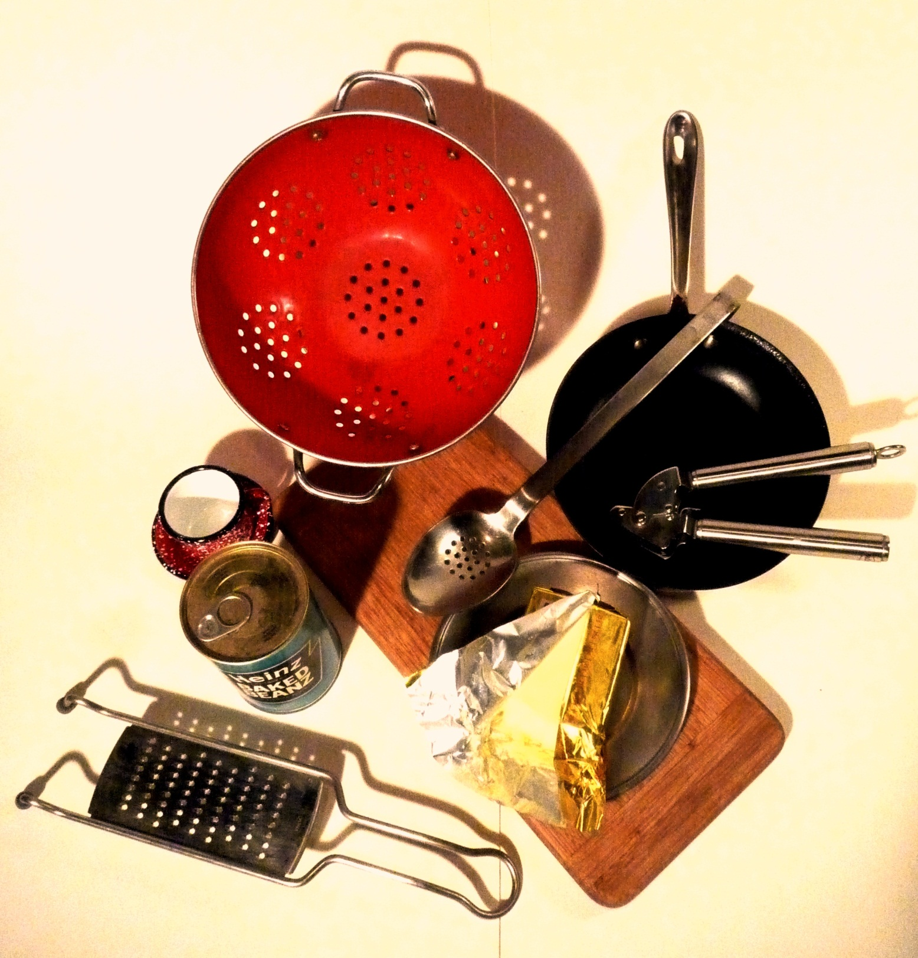

Picture 2

Picture 3

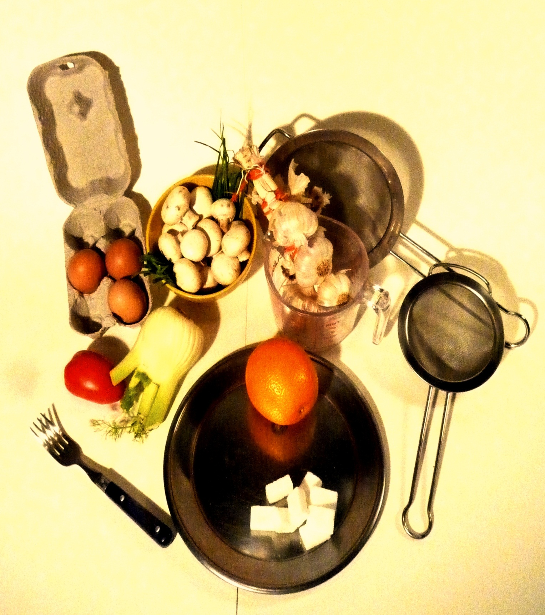

Brainstorming:

Cooking Vocabulary

1/ Which cooking vocabulary (nouns) do you know?

________________________ ________________________ ________________________

________________________ ________________________ ________________________

________________________ ________________________ ______________________

2/ Which verbs and actions related to cooking do you already know?

________________________ ________________________ ________________________

________________________ ________________________ ________________________

________________________ ________________________ ________________________

Cooking vocabulary

Divide the words written out on the board into word categories.

Word category 1:

________________________ ________________________ ________________________

________________________ ________________________ ________________________

________________________ ________________________ ________________________

Word category 2:

________________________ ________________________ ________________________

________________________ ________________________ ________________________

________________________ ________________________ ________________________

Word category 3:

________________________ ________________________ ________________________

________________________ ________________________ ________________________

________________________ ________________________ ________________________

Word category 4:

________________________ ________________________ ________________________

________________________ ________________________ ________________________

________________________ ________________________ ________________________

